# DEPARTMENT OF ELECTRONICS AND TELECOMMUNICATION



**College Name**  -Kolhapur Institute Of Technology’s, College Of

Engineering, Kolhapur

**Course Name**  -Electronics & Tele-communication

# Project Title - “Attendance Monitoring Face Recognitions”

**Project Guide** -Mr**.** E. C. Patil

**Research Students -** Shreya Sajay Mohire (41)

Rushikesh Pradeep Pawar (56)

Swarada Chandrashekhar Phadnis(57)

**TABLE OF CONTENTS**

|  |  |  |
| --- | --- | --- |
| **SR. NO.** | **TITLE** | **PAGE NUMBER** |
| 01 | Introduction | 03 |
| 02 | Design | 04 |
| 03 | Implementation | 06 |
| 04 | Conclusion and future enhancement | 09 |
| 05 | Reference | 10 |

**INTRODUCTION**

* Scope and importance :-

A facial recognition system is a technology capable of identifying or verifying a person from a digital image or a video frame from a video source. There are multiple methods in which facial recognition systems work, but in general, they work by comparing selected facial features from given image with faces within a database. It is also described as a Biometric Artificial Intelligence based application that can uniquely identify a person by analyzing patterns based on the person's facial textures and shape.

While initially a form of computer application, it has seen wider uses in recent times on mobile platforms and in other forms of technology, such as robotics. It is typically used as access control in security systems and can be compared to other biometrics such as fingerprint or eye iris recognition systems. Although the accuracy of facial recognition system as a biometric technology is lower than iris recognition and fingerprint recognition, it is widely adopted due to its contactless and non-invasive process. Recently, it has also become popular as a commercial identification and marketing tool. Other applications include advanced human-computer interaction, video surveillance, automatic indexing of images, and video database, among others.

# DESIGN

# BLOCK DIAGRAM

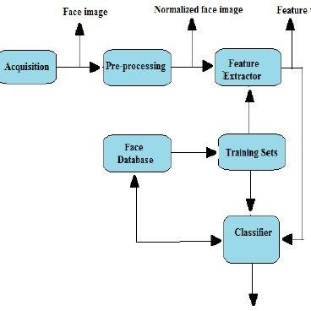

**Working system**

Face recognition is the main step for this paper because it really contributes a greatest part in the surveillance application. Without Recognition it is simply not useful when it comes to surveillance application. In order to recognize a face, we used the following approach, Face is a completely a complex multidimensional structure. Therefore, there is a need to compute better recognition techniques. Out of which we follow some approaches to process face recognition. They are Principle Component analysis (PCA) and Eigen face approach. These are explained below, 1) PCA: It is a variable reduction method of an image. The method can be described below, a) The given image is converted into gray scale images because it is easier for computation. b) The converted gray scale image is scaled to particular size because the input images that we collect are of different size. c) Therefore, we develop a training set where we have for different conditions. We have images of different sizes, illuminations, expressions etc. for face recognition. d) Testing Conditions: If there will be a change in expression or illumination or size of image or the recognition procedure may change

**IMPLEMENTATION**

Circuit Diagram :-

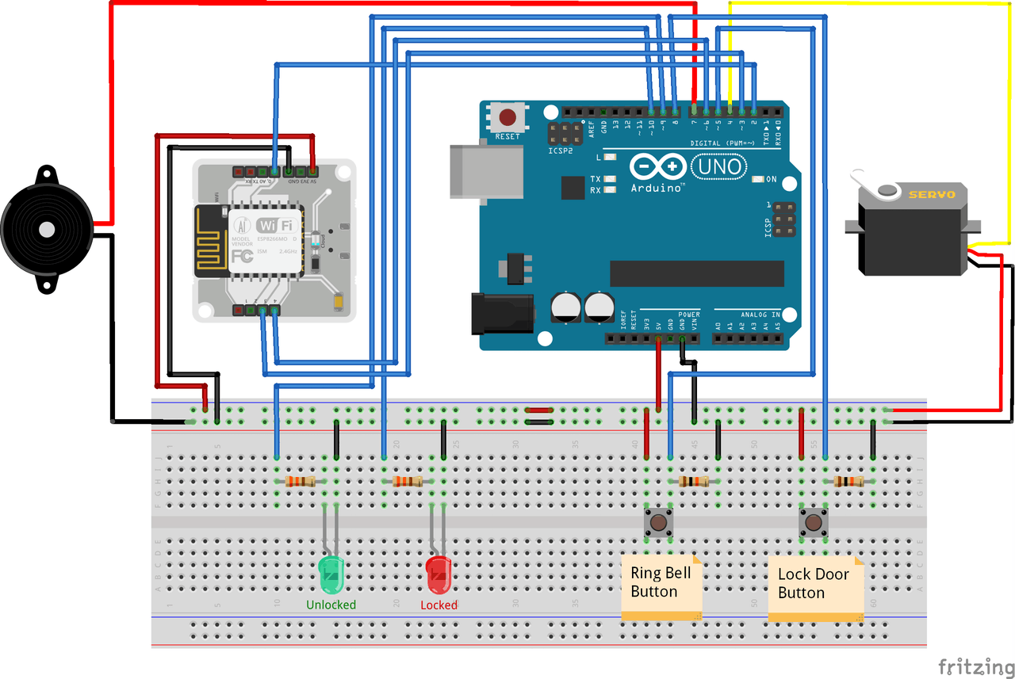

# Tools / Technique used in project hardware-

1. Arduino UNO
2. Push button
3. 12V Power supply for Arduino
4. Connecting wires
5. Buzzer
6. Camera
7. Register

**Component Description**

1. **Arduino** :- Interfacing with the sensors and other IOT parts require the Arduino. The Arduino uno 3 doesn’t interface with camera but the other models of Arduino can interface with camera.

Specification :-

|  |  |
| --- | --- |
| Operating Voltage | 5V |
| Recommended Input Voltage | 7-12V |
| Input Voltage Limits | 6-20V |
| Analog Input Pins | 6 (A0 – A5) |
| Digital I/O Pins | 14 (Out of which 6 provide PWM output) |
| DC Current on I/O Pins | 40 mA |
| DC Current on 3.3V Pin | 50 mA |
| Flash Memory | 32 KB (0.5 KB is used for Bootloader) |
| SRAM | 2 KB |
| EEPROM | 1 KB |
| Frequency (Clock Speed) | 16 MHz |

1. **Camera** :-

The interfacing of the camera can be done by the Arduino, rasp berry pie, TIVA board.

* Full HD 1080p video calling (up to 1920 x 1080 pixels) with the latest version of Skype for Windows  
   720p HD video calling (up to 1280 x 720 pixels) with supported clients
* Full HD video recording (up to 1920 x 1080 pixels)
* H.264 video compression
* Built-in dual stereo mics with automatic noise reduction
* Automatic low-light correction
* Tripod-ready universal clip fits laptops, LCD or monitors

1. **Buzzer** :- In this circuit, if the image stored in the memory is not matched with the current image then the buzzer will turn on.

Specification :-

* Rated Voltage: 6V DC.
* Operating Voltage: 4-8V DC.
* Rated current: <30mA.
* Sound Type: Continuous Beep.
* Resonant Frequency: ~2300 Hz.

1. **Push Button** :- This is just to initiate the circuit.

Specification :-

* Mode of Operation: Tactile feedback
* Power Rating: MAX 50mA 24V DC
* Insulation Resistance: 100Mohm at 100v
* Operating Force: 2.55±0.69 N
* Contact Resistance: MAX 100mOhm
* Operating Temperature Range: -20 to +70 ℃
* Storage Temperature Range: -20 to +70 ℃

**CONCLUSION**

This face recognition system is used in various fields banking, retailing , marketing, online transaction, medical, advertising, marketing. Attendance monitoring becomes easier using this face recognition. A way to utilize face recognition technology is by placing cameras. That way it is possible to analyze and improve the students attendance by accessing student’s information from their profiles.

**FUTURE ENHANCEMENT**

* One of the fields that uses facial recognition the most is security. Facial recognition is a very effective tool that can help law enforcers recognize criminals and software companies are leveraging the technology to help users access their technology.
* This technology can be further developed to be used in other avenues such as ATMs, accessing confidential files, or other sensitive materials. This can make other security measures such as passwords and keys obsolete.
* Another way that innovators are looking to implement facial recognition is within subways and other transportation outlets. They are looking to leverage this technology to use faces as credit cards to pay for your transportation fee. Instead of having to go to a booth to buy a ticket for a fare, the face recognition would take your face, run it through a system, and charge the account that you’ve previously created. This could potentially streamline the process and optimize the flow of traffic drastically.

**REFERENCE:-**

* Face recognition based smart attendance paperback

by Arun Mozhi Devan Panneer Selvam

* Face Recognition using Principal Component Analysis & Neural Network

by U. K. Jaliya

* New Approaches to Characterization and Recognition of Faces Paperback

by Peter M. Corcoran

* Handbook of Face Recognition Paperback

by Stan Z. Li. And Anil K. Jain editors

* <https://indatalabs.com/>

InData Labs, data science firm and AI-powered solutions provider with its own R&D center